FOREIGN TRADE UNIVERSITY
VIETNAM-JAPAN SCHOOL OF BUSINESS AND INNOVATION

==***==


FINAL REPORT
ADVANCED BUSINESS ANALYTICS

HOTEL BOOKING CANCELLATION DECISION SUPPORT
CITY HOTEL LISBON

Group: 2
Class: DBZ405E(DB-HK1-2627)K62.1
Lecturer: GS. Hồ Tú Bảo, PGS.TS. Trần Thị Oanh

Ha Noi, 2026

MEMBER CONTRIBUTION
NAME | STUDENT ID | TASKS | %
Vũ Minh Trang | 2313560046 | Data architecture diagram/schema, Description of data sources and features, Example data extract/simulated sample, Integration challenges and privacy/ethical issues
Vũ Minh Thư | 2312560044
Phạm Lương Duyên | 2313560009
Trần Ngọc Thành | 2312560042
Nguyễn Thị Minh Thư | 2311560045 | Strategic problem statement, High-level PDMT map, Expected business value, Cross-functional business problem
Lý Vân Ngọc | 2314560032
Hoàng Thị Thùy Dương
Nguyễn Quốc Tuấn

TABLE OF CONTENT

1. Strategic Problem Statement 5
1.1. Business Context 5
1.2. Business Pain Points 5
1.3. Stakeholders 6
1.4. Decisions to Improve 7
1.5. Strategic Objectives 7
1.6. SCQ Framework 8
2. PDMT Map 8
3. Expected Business Value 9
4. Data 11
4.1 Data sources and audit 11
4.2 Data architecture and schema 11
4.3 Data sources and features 12
4.4 Data preparation 13
4.5 Exploratory analysis and leakage checks 14
4.6 Example data extract 14
4.7 Integration challenges 14
4.8 Privacy and ethics 15
5. Method 15
5.1. Method 1: Cancellation Risk Prediction (ML) 15
5.1.1. Purpose and scope 15
5.1.2. Analytical design 15
5.1.3. Prototype analysis (mock results) 16
5.1.4. Evaluation plan 17
5.2. Method 2: Risk-Based Decision Rules and Business Value 18
5.2.1. Purpose and scope 18
5.2.2. Analytical design 18
5.2.3. Prototype analysis (mock results) 21
5.2.4. Evaluation plan 23
6. Tools and System Prototype 24
6.1. Technology Stack 24
6.2. Data Integration and Analytical Outputs 26
6.3. System Architecture and Workflow 27
6.4. Dashboard and Automation Process 27
6.5. Verification and Limitations 31
7. Implementation Roadmap 31
REFERENCES 33

Strategic Problem Statement

Business Context
Scenario: City Hotel Lisbon sells perishable room inventory ahead of arrival, largely through travel agents and operators. Until the guest arrives, revenue is only expected, not secured.
Strategic issue: Revenue-management research identifies booking cancellations as a core source of demand uncertainty: they limit the accuracy of forecasts, and the usual responses, rigid cancellation policies and overbooking, can themselves damage revenue and reputation (Antonio et al., 2017). For City Hotel Lisbon, this means expected revenue and room plans cannot be fully relied on, and blanket policies are an imperfect fix. Cancellation is therefore a strategic revenue-risk problem, not just an operational event. Its scale is quantified in Section 1.2.
Cross-domain impact: One cancellation touches several domains at once, yet each is managed separately today, so no single view supports a joint decision.
Domain | Current state | Gap the project addresses
Distribution / Marketing | Cancellation risk differs sharply by channel and segment, but is not used in booking management | Segment and agent risk guides follow-up priority and group-block contracts
Customer Experience | At-risk guests are not systematically contacted | Proactive, targeted contact for high-risk bookings only
Finance | Commission, handling cost and revenue at risk are not linked | Net value of actions accounts for cost
Operations | Freed rooms are not systematically resold | Resale and capacity decisions are guided by cancellation risk
Transformation opportunity. Integrating booking, customer, cost and inventory data into one decision-support system can shift the hotel from reactive handling to risk-based, proactive booking management, optimizing revenue and room capacity.

Business Pain Points
Baseline: City Hotel Lisbon, 79,330 bookings, July 2015 - August 2017 (Antonio, Almeida & Nunes, 2019).
Pain point | Supporting data | Why it matters
Limited visibility into cancellation risk | 41.7% of bookings (33,102) were cancelled or no-show. Most cancellations come weeks ahead (median 58 days before arrival); 12.0% come within 7 days (14.5% if no-shows count as 0-day notice) | Most cancellations can still be acted on weeks before arrival, but only if risk is known early. Late cancellations leave the least time to resell the room, so they are handled through a capacity buffer rather than guest contact
Inefficient allocation of follow-up resources | Travel agents and operators handle 87% of bookings. Cancellation rates differ by segment: Direct 17.3%, Online TA 37.4%, Groups 68.9%. Group and Non Refund blocks need contract-level action; individual guests need booking-level follow-up. At-risk guests are not systematically contacted (assumed current practice) | Risk varies widely across segments, so uniform follow-up wastes effort on safe bookings and misses risky ones. Hospitality churn research supports targeting only high-risk guests rather than contacting everyone (van Leeuwen et al., 2025)
Limited ability to optimize revenue and room capacity | €10.9M of €25.3M gross booked room revenue (about 43%) is tied to cancelled bookings. Resale of freed rooms is not guided by risk, and commission and handling cost are not linked to risk (assumed current practice) | The hotel cannot tell which bookings to act on, or how to adjust follow-up, pricing, capacity allocation and resale so that revenue and occupancy are optimized net of intervention cost.  Revenue-management studies show that cancellation-aware allocation and pricing decisions can raise profit in simulation (Dong & Ling, 2015; Cha, 2026; Pimentel et al., 2019)
Note: €10.9M is gross booking value exposed to cancellation, not realized loss. Some of it is resold or recovered through deposits.

Stakeholders
Group | Role | Interest
General Manager, Revenue Manager | Decision-makers | Set priorities, resources and booking-management strategy; optimize revenue and capacity
Reservation Team | Operational users | Use risk information to follow up with guests and flag freed rooms to the Revenue Manager
Customer Service / CX | Operational users | Design and send guest messages; own opt-outs and CX KPIs
Finance | Decision support | Own cost and contribution assumptions; judge net value and ROI of interventions
Distribution / Sales | Operational users | Manage agents, tour operators and group-block contracts (release dates, deposits)
Data / Analytics Team | System owners | Build the model, check its calibration and monitor drift
Guests | Affected party | Experience the interventions; not direct system users

Decisions to Improve
Decision | Business question | Supported by
Risk identification | Which bookings are more likely to be cancelled? | Machine Learning
Resource prioritization | Which bookings should staff handle first when resources are limited? | Risk score + value proxy
Intervention selection | Should the hotel confirm, send a reminder or contact the guest directly? | Business rules
Revenue and capacity optimization | Which follow-up, capacity-allocation and resale actions improve revenue and occupancy at a justified cost, and would price adjustment add value? | Rule-based analysis + ROI analysis
Only the first decision is addressed directly by ML. The others need business rules, operational data and impact evaluation.

Strategic Objectives
Each objective follows from a pain point and a decision, and is backed by evidence.
 | Objective | Addresses pain | Improves decision | Evidence basis
1 | Identify cancellation risk at booking time, while there is still time to act | Limited visibility | Risk identification | 41.7% cancellation rate; median notice 58 days; 12.0% within 7 days
2 | Allocate follow-up effort to the highest-risk, highest-value bookings | Inefficient allocation | Resource prioritization; intervention selection | Segment gap from 17.3% (Direct) to 37.4% (Online TA) among individual bookings, 68.9% for Groups; threshold-based targeting (van Leeuwen et al., 2025)
3 | Optimize revenue and room capacity by supporting follow-up, capacity-allocation and resale decisions net of intervention cost, and test price adjustment as a scenario | Limited ability to optimize revenue and capacity | Revenue and capacity optimization | €10.9M exposure; profit gains in simulated revenue-management studies (Dong & Ling, 2015; Cha, 2026; Pimentel et al., 2019)
Targets are reference pilot goals, to be confirmed through model evaluation and a randomised pilot.

SCQ Framework
Situation | City Hotel Lisbon sells rooms in advance. Over July 2015 - August 2017, 41.7% of 79,330 bookings were cancelled or no-show, tying up €10.9M of €25.3M gross booked room revenue.
Complication | Most cancellations arrive weeks ahead (median 58 days), and 12.0% within 7 days, when resale is hardest. Risk differs sharply by segment (Direct 17.3%, Online TA 37.4%, Groups 68.9%), yet at-risk guests are not systematically contacted and cost is not linked to risk. With roughly 80 new individual bookings a day, manual review of every booking is not scalable.
Question | How might City Hotel Lisbon predict booking cancellation risk early, prioritize high-risk bookings, and recommend proportionate interventions to optimize revenue and room capacity?

PDMT Map
The map links the strategic problem (Section 1) to the data (Section 4), the two methods (Section 5) and the tools (Section 6), and to the business value expected from them (Section 3).

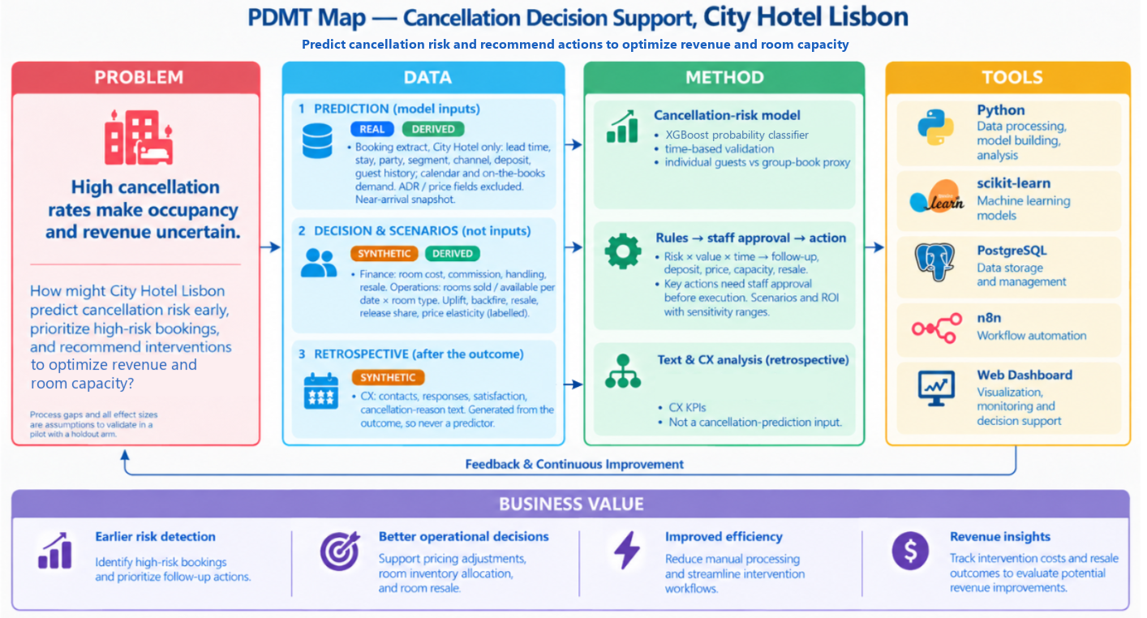

Expected Business Value
Baseline: City Hotel Lisbon, Jul 2015-Aug 2017 (41.7% cancellation rate). Targets without a sound benchmark will be set from model evaluation and baseline analysis. External benchmarks are pilot references from other settings.
Business function | Expected value and target | Evaluation and data
1. Cancellation risk prediction | Rank risk better than simple rules at the team’s real capacity: Recall@20% at least equal to a segment × lead-time rule, Precision@20% ≥ 50% and Lift@20% ≥ 1.5 on a later, time-ordered test set (a 20% queue caps recall at about 58%). | Recall, Precision, PR-AUC vs. a baseline model on an independent test set. Data: is_canceled and booking-time features (lead_time, previous_cancellations, market_segment, distribution_channel, customer_type, agent); deposit_type and booking_changes are excluded to avoid leakage.
2. Risk-based prioritisation | Focus staff on the bookings with the most value at risk: each week, call the top 15% by risk × booking value and send reminders to the next 45%, within 20 call tasks a day. | Cancellation rate and share of cancelled value in the call and contact tiers, against the cancellation rate of the same weekly queue (2017: call tier 38.3% vs. 24.0%). Data: model risk score, booking value, is_canceled.
3. Customer experience and retention | Pilot target: a lower cancellation rate in the contacted tiers than in a randomised holdout, with no rise in opt-outs or complaints. Break-even is low: a call pays for itself if it prevents 1.1% of the cancellations it reaches, a reminder 2.0%. | Retention uplift (pp) = Retention(contact) − Retention(control); also response and cancellation rates. A control group is required for a causal claim. Data: contact_attempted, contact_channel, customer_response, is_canceled.
4. Finance and revenue recovery | Simulated net benefit of EUR 30.4k a year after variable costs and backfire losses; 3-year programme ROI of 173% and payback of 6.9 months from full roll-out (month 23 of the roadmap) after a EUR 15.6k one-off cost and EUR 3.4k a year running cost (Section 5.2). Assumption-based until the pilot measures the effect.  Reference: about 4% hotel profit gain from revenue-management optimisation (4.20% in a simulated overbooking scenario; Dong & Ling, 2015; see also Pimentel et al., 2019). A model benchmark, not a guaranteed gain. | Net recovery = Rebooking revenue − Incremental costs (commission, handling, staff). The €10.9M gross figure is not net recovery. Staff-cost floor: Portugal minimum wage €505–557 per month, 2015–2017 (Hans-Böckler-Stiftung, n.d.).
5. Room inventory and operations | Reference: at least 2.3% higher contribution profit when decisions are updated over time rather than optimised once (2.27% weekly booking-limit update; Cha, 2026). A dynamic-optimisation benchmark, not a resale-rate benchmark. | Resale rate = Rooms resold after cancellation ÷ Cancelled rooms eligible for resale; also unsold room-nights by arrival date. Compare operations with and without cancellation prioritisation.

Data
The data combine one real PMS extract with simulated tables that fill its gaps. Every field is labelled REAL, DERIVED (computed from real data), SYNTHETIC (simulated from a documented assumptions register) or SYSTEM (written later by the model, rules and n8n), so simulated figures are never presented as facts.

4.1 Data sources and audit
- Source: City Hotel Lisbon bookings from a hotel PMS extract (Antonio et al., 2019): 79,330 of the file's 119,390 rows, arrivals July 2015 - August 2017, values recorded the day before arrival. The target is_canceled covers cancellations (40.6%) and no-shows (1.2%). The data are anonymised and match the published description on every check.
- Audit:
Issue | Finding | Decision
Missing values | company 95.4% and agent 10.3% empty (= none); country 24 rows, children 4 rows | Flag or fill
Duplicates | 25,902 rows (32.7%), mostly Groups; cancel 66% vs 30% | Likely block bookings: flag, keep
Invalid values | One ADR of EUR 5,400; 700 paid bookings with ADR 0; 331 zero-night and 167 zero-guest rows | Flag; impossible rows excluded
- Preliminary EDA: the cancellation rate rises from 12% for bookings made 0–7 days ahead to 71% beyond a year; median notice is 58 days, so many cancelled rooms can in principle be resold.
- Data gaps: The data predict well but lack what revenue decisions need: 12 of 17 data needs are missing, mainly room cost, commission, inventory, resale and guest contact. These are filled with labelled synthetic tables (Section 4.3); intervention uplift can only come from a pilot.

4.2 Data architecture and schema
All tables share one key, booking_id: booking-level tables join 1:1, and room inventory joins through the nights each booking covers.
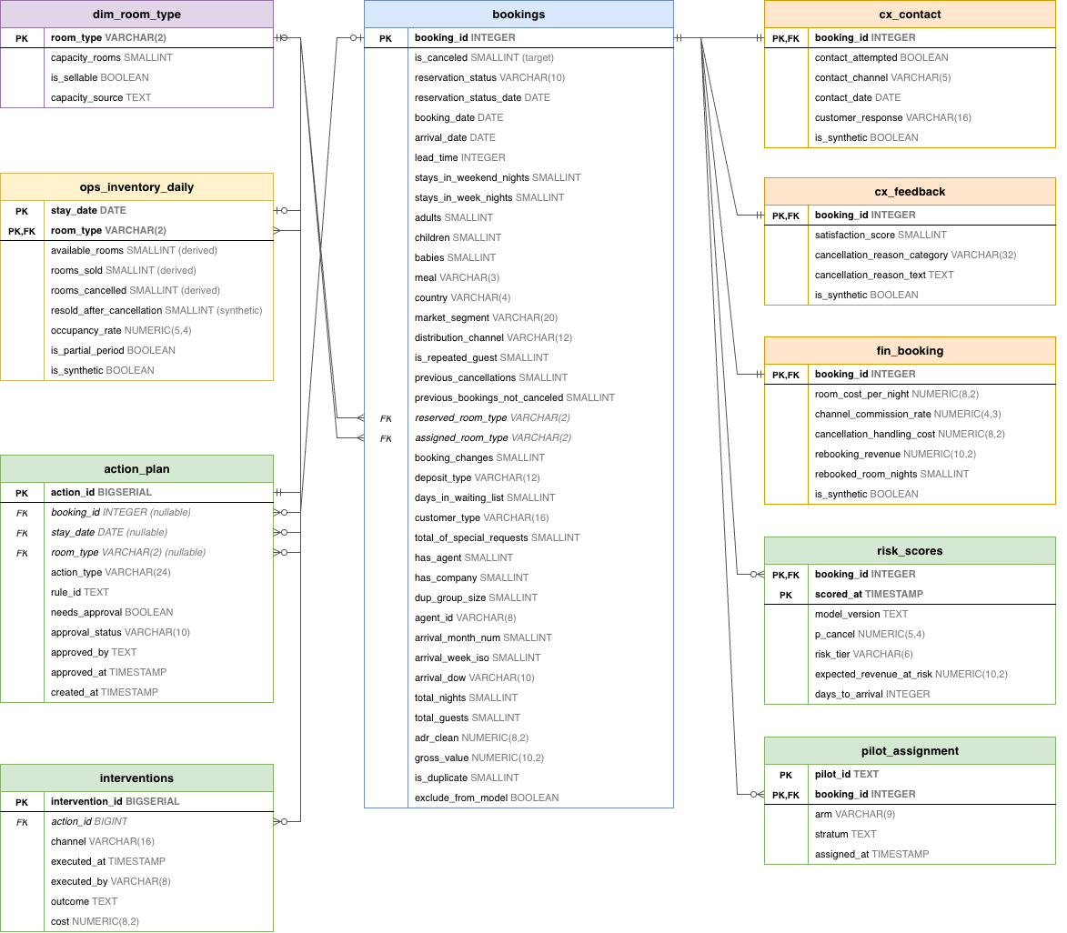
Figure 4.1. Data architecture

Simulated tables feed value-at-risk and scenarios, never the classifier. The schema runs in PostgreSQL with keys and CHECK constraints (for example, an action needing approval cannot run automatically) and passes 30 of 30 load checks; all 100 fields are documented in a data dictionary.

4.3 Data sources and features
- Simulated data: All values come from one assumptions register, sourced for Lisbon or Portugal 2015-2017 where possible, each with a sensitivity range.
Field | Base value | Basis
Room cost per night | 27% of median ADR (room type × month) | Mandelbaum & McDade, 2017; Rushmore, 2011 (proxy); range 25-30%
Channel commission | Online TA 18%, Offline TA/TO 20%, Groups 10%, Direct 0% | Online TA: Toulon (2014), weighted by OTA shares (Schegg, 2018). Offline TA/TO and Groups: team assumption.
Handling cost | 8-15 minutes × EUR 9.40 per hour | (“Salários médios sobem,” 2018)
Deposit retained | 0% (Non Refund tested up to 100%) | Team assumption: amount not recorded
Resale | 10-70% by notice × demand, at 90% of ADR | Team assumption; capped by rooms actually sold
Room capacity | 252 rooms (peak occupancy per type) | Derived; 71.3% occupancy in 2016.
On these assumptions, 50.7% of cancelled room-nights are resold, and cancelled bookings lose about EUR 3.8M in contribution net of resale. The loss falls to EUR 0.6M if Non Refund deposits are kept, so the deposit assumption matters most.
- Model features: The individual model uses 39 booking-time features (32 numeric, 7 categorical): lead time, season, stay, party, guest history, top-15 agent and bookings on the books. Outcome fields, assigned room, country, booking_changes and price fields (ADR and its derivatives) are never used as features. Feature statistics are fitted on each training fold only.

4.4 Data preparation
Cleaning keeps all 79,330 rows and flags problems instead of deleting them. Only 438 impossible rows (0.55%: zero guests or nights, the ADR error, undefined segment) are excluded, leaving 78,892 for modelling. Duplicates are kept and flagged, and results are reported with and without them. The simulated tables pass 39 validation checks and are joined 1:1 with the prefix syn_.
Bookings are split into two populations because they need different decisions:
Population | Rule | Bookings | Cancel rate: 2015-16 → 2017
Individual | All other bookings | 52,676 | 28.0% → 34.4%
Group / block | Groups segment, Non Refund deposit, or 5+ identical bookings | 26,216 | 64.2% → 66.7%
Data are split by arrival date: 2015–2016 for model development (rolling-origin folds within 2016) and January–August 2017 for testing.

4.5 Exploratory analysis and leakage checks
- Strongest signals: deposit type, agent, segment and lead time. Among individual guests the signal is weaker (special requests, last-minute booking, lead time); season matters less (monthly rates 37–46%).
- Group blocks cancel early (median 83 days before arrival) and in batches; individuals cancel later (36 days) and one by one.
- Drift 2016 → 2017: new agents (PSI 1.09) and median ADR +16.5%, so agents are grouped as top 15 + others (rebuilt in each training fold) and price fields are left out of the model.
- Leakage: Fields not known at scoring time are excluded: reservation status, booking_changes, assigned room type, parking requests, realised occupancy and all simulated fields. 'Country' is excluded for fairness and because its booking-time value is unverified. EDA saw 2017 labels, so model choice and thresholds use the 2016 folds only.

4.6 Example data extract
A 30-booking stratified extract marks the origin of every column (real__, drv__, syn__). Three rows:
Case | Segment, deposit | Gross value (EUR) | Room cost per night (syn, EUR) | Commission (syn) | Resale revenue (syn, EUR)
Stayed, contacted by email | Online TA, No Deposit | 324.90 | 25.34 | 18% | -
Cancelled, resold | Online TA, No Deposit | 535.50 | 25.49 | 18% | 200.37
Cancelled, not resold | Groups, Non Refund | 192.00 | 24.70 | 10% | 0.00

4.7 Integration challenges
Challenge | Design response
Several systems (PMS, channel manager, email/SMS, accounting) with different IDs | One PostgreSQL schema keyed on booking_id, plus an ID mapping table
Booking-level vs night × room-type data | Separate tables joined through stay nights
Snapshot data vs live scoring | Time-stamped scores and actions; production keeps booking-change history
Real-time inventory | Production: refreshed by n8n from the PMS. Prototype: synthetic table loaded in batch.

4.8 Privacy and ethics
The public data are anonymised; a live system would fall under the GDPR, so the design adds four safeguards:
- Minimisation: the model uses no names or contacts; personal data stay in a separate, access-controlled table.
- Human review: change offers, deposit requests, and room or price changes need staff approval (General Data Protection Regulation, 2016, Art. 22).
- Fairness: country is excluded from the model, and actions are monitored by segment and channel so no guest group is unfairly burdened.
- Transparency: guests are told that bookings are risk-scored, and reports label every simulated figure.

Method

5.1. Method 1: Cancellation Risk Prediction (ML)

5.1.1. Purpose and scope
Purpose: Score each individual booking by its cancellation risk at an early stage, so staff can prioritise a limited number of bookings for follow-up. The model ranks bookings. It does not make the final decision. The ranked list feeds Method 2 (rules → staff approval → action).
Scope:
- Individual bookings only. Group bookings (group_block) follow a separate operational rule.
- Target: is_canceled (cancelled or no-show).
- Data: real PMS extract, City Hotel Lisbon, Jul 2015 - Aug 2017.

5.1.2. Analytical design
Flowchart:
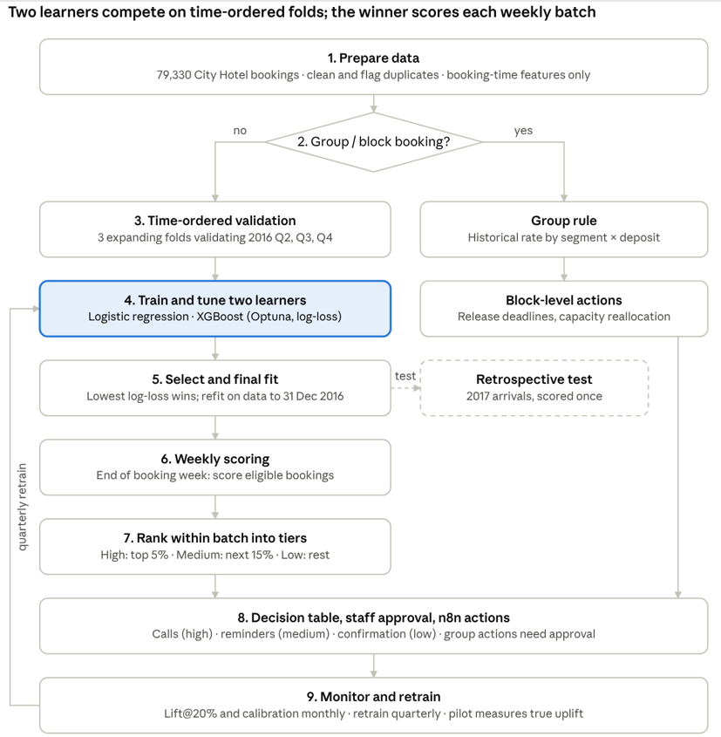
Figure 1. Method 1 analytical pipeline

Model selection rationale:
We select models by how often their families appear in hotel-cancellation research and by what each does in a binary classification problem (Alkan, 2025; Chen et al., 2022; Hermawan et al., 2025; Luo, 2025; Yoo et al., 2024). XGBoost and Logistic regression appear in most of the studies.
What each model means for this classification problem:
- XGBoost: captures non-linear effects and interactions such as agent × lead time, and handles mixed tabular data.
- Logistic regression (benchmark): gives odds ratios managers can read and stable probabilities
These two models represent a linear and a boosting approach. They suit our data: 79,330 bookings, mixed numeric and categorical features, threshold effects (lead time) and interactions (deposit × segment). Both output probabilities, which the weekly ranking into tiers requires. The dataset is small enough for every model to receive the same tuning budget, so the comparison is fair.

5.1.3. Prototype analysis (mock results)
On 2017 data the model ranks risk clearly better than the hotel's best simple rule; results are retrospective and the weekly queue is simulated.

Scorer | AUC | PR-AUC | Brier | Precision@5% | Precision  @20% | Lift  @20%
XGBoost | 0.736 | 0.556 | 0.192 | 66.2% | 58.3% | 1.70
Rule: segment × lead time | 0.678 | 0.468 | 0.206 | 54.1% | 50.8% | 1.48
Logistic regression (lead time + segment) | 0.676 | 0.493 | 0.209 | 61.5% | 50.9% | 1.48
Random / constant | 0.500 | 0.344 | 0.230 | 34.4% | 34.4% | 1.00
- Gain over the rule: +308 cancellations caught in the same top 20% (bootstrap CI for precision: +5.4 to +10.0 points).
- Ranking: the top decile cancels 60.7%, 8.5 times the lowest (7.2%); ranking by expected loss puts 52% of cancelled revenue in the top 20% (random: 20%).
- Drivers: travel agent, lead time, customer type, length of stay (associations, not causes).
Simulated weekly queue 2017 (12,102 eligible bookings): High tier (4.9%, about 4 calls/day) cancelled 46.2%, Medium (15.0%, reminders) 39.4%, Low (80.1%, standard confirmation) 19.8%. At equal capacity the model catches 139 more cancellations than the rule (95% CI 48–232). These are Method 1's default tiers (5% / 20%); the operating policy uses the G1 tiers of Method 2 (top 15% called, up to 60% contacted, Section 5.2).

5.1.4. Evaluation plan
The method is evaluated in three steps: model accuracy (done offline), queue performance (simulated, then shadow-run), and business impact (randomised pilot).
KPI | Target | 2017 result
Recall@20% | ≥ rule | 33.9% vs 29.5%
Precision@20% / Lift@20% | ≥ 50% / ≥ 1.5 | 58.3% / 1.70
PR-AUC, Brier | better than baseline LR | 0.556, 0.192 vs 0.493, 0.209
Revenue captured@20% | ≥ 50% (expected loss) | 52.2%
- Validation: time-ordered folds only, leakage controls inside each fold, one test pass, paired bootstrap against rules; robust to duplicates and group-rule changes (AUC 0.735–0.740).
- Monitoring: monthly Lift@20% and predicted vs actual rate. The model is frozen during the pilot so that treatment and holdout are compared under one policy; quarterly retraining starts at roll-out, since AUC fell from 0.80 to 0.71 during 2017. The dashboard's Model monitoring page recomputes these figures on the bookings that arrived before today (on 1 May 2017: 4,315 bookings, ROC-AUC 0.740, Lift@20% 1.92), not on notebook results that include later arrivals.
- Pilot: randomised treatment vs holdout; compare stay rate and net contribution by assigned arm, with complaint guardrails; scale up only if uplift is positive.

Limitations:
- Near-arrival snapshot data. Lead time, number of guests and room type are final values, not the values at the time of booking. All results are therefore retrospective, including the simulated weekly queue. They do not show how a live system would perform. Operational testing requires a snapshot or event log captured at scoring time.
- The group_block definition is inferred. It is not a label available in the data.
- Limits of the simulated queue. The queue includes only bookings created in weeks ending after 31 Dec 2016. There is no data on consent, opt-out or open actions. Summer weeks are missing bookings for arrivals after 31 Aug 2017.
- Summed probabilities by arrival week are not an operational room forecast.
- Detection is not prevention. How many cancellations and how much revenue are actually “retained” depends on how well the interventions work. That figure must be measured through a randomised pilot with a holdout group (pilot_assignment). It cannot be inferred from simulated or synthetic contact data.

5.2. Method 2: Risk-Based Decision Rules and Business Value

5.2.1. Purpose and scope
Purpose: Convert the Method 1 risk score into weekly staff actions and test whether they pay off: which bookings to act on, what to do with each, and the net gain after all costs.
Scope:
- Units: individual bookings scored by the final Method 1 model (XGBoost). Group blocks follow separate rules (G1–G3), all approved by the Revenue Manager.
- Decision time: end of each booking week, covering bookings created that week that are still active and not yet arrived.
- Evaluation: 2017 operational queue (12,102 individual bookings, 35 weekly batches, 24.0% cancelled). The policy was chosen on 2016 data and frozen before 2017 was read.
- Money: contribution basis (room revenue net of commission, minus room cost). Uplift, cost and resale inputs are assumed or simulated (Section 4), not observed.

5.2.2. Analytical design
Step 1: Tier each weekly batch. The call tier is the top 15% by p_cancel × booking value, so calls target the most money at stake. The reminder tier takes the next bookings by p_cancel up to 60% coverage. The low tier is the remaining 40%. Shares and ranking key were chosen from 42 candidate policies on 2016 batches, using models fitted only on data available before each decision. Batch shares, unlike a fixed cut-off, keep workload stable when scores drift.

Step 2: Route each booking to an action (Figure 5.2):
Rule | Condition | Action | Owner | Approval
I1 | Low tier, or reminder tier ≤ 7 days to arrival | Standard confirmation + reminder 7 days before arrival (current practice) | n8n, monitored by Reservations | Weekly plan review, then automatic
I2 | Reminder tier, ≥ 8 days | Personalised e-mail/SMS at 30 and 14 days (max 2) | n8n, monitored by Reservations | Weekly plan review, then automatic
I3 | Call tier, ≥ 8 days | Call within 7 days of decision, ≥ 8 days before arrival; max 20 tasks/day; unslotted tasks → manual review | Reservations | Weekly plan review (internal task)
I4 | Guest requests change during I3 call | Offer date or room change | Reservations | Revenue Manager (every offer in the prototype)
I5 | Call tier, ≤ 7 days | No contact; count in date × room-type cancellation buffer | Revenue Manager | –
I6 | Call tier, no deposit, high value | Request deposit (off by default) | Reservations | Revenue Manager (GDPR Art. 22)
G1 | Group block, risk ≥ 0.5, > 30 days ahead | Ask agent to confirm or release block 30 days before arrival (valued in scenario S5; not yet an action in the prototype) | Distribution / Sales | Revenue Manager
G2 | Released or forecast-cancelled rooms | Reallocate capacity; return rooms to sale | Revenue Manager | Required
G5 | Price change on a date × room type | Adjust price (no tested price limits yet) | Revenue Manager | Required
G3 | High forecast cancellations on high-demand date | Controlled overbooking (disabled; exploratory only) | Revenue Manager | GM sets limits
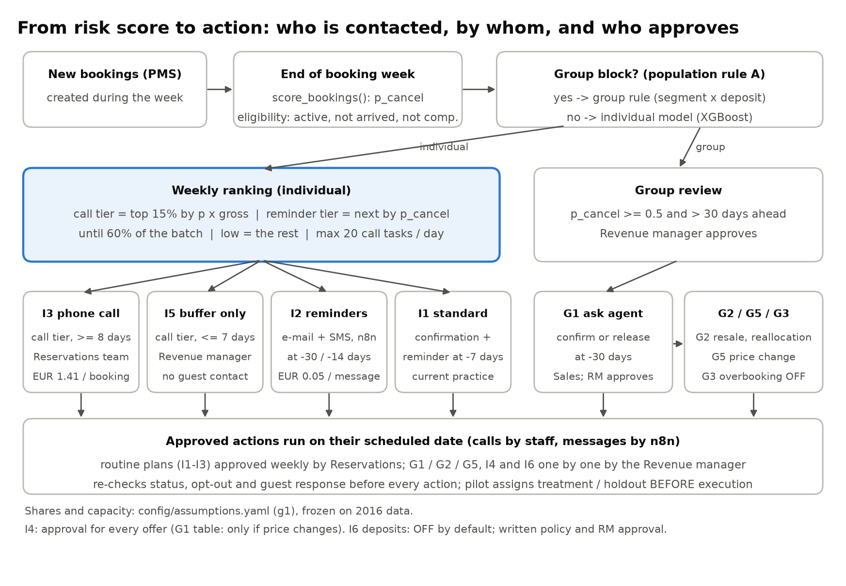
Figure 5.2. Decision workflow: from risk score to action
In production, n8n runs automatic actions on schedule after re-checking booking status, opt-out and guest response. In the prototype (Section 6), these checks, the call window and the daily limit run in the dashboard and in a demo n8n workflow that sends nothing. Actions affecting price, capacity or guest obligations require approval.

Step 3: Value each action.
- Benefit: for a booking that would have been cancelled, contact prevents a share of cancellation (uplift). Each prevented cancellation is worth its contribution minus what would have been recovered anyway (resale contribution − handling cost + any deposit kept). Late cancellations are worth more, as rooms are harder to resell.
- Backfire: since 99.96% of individual bookings are No Deposit and free to cancel, a reminder may trigger a cancellation that would not otherwise occur. This loss is subtracted.
- Costs: EUR 1.41 per call task (6 min × 1.5 attempts at EUR 9.40/h) and EUR 0.05 per SMS, with none for bookings cancelling before contact. Programme: EUR 15,564 one-off (integration, n8n workflows, dashboard, training) + EUR 3,360/year (hosting, monitoring).
- Base assumptions: uplift 10% (calls) / 3% (reminders); backfire 0% / 0.5%. Reminder uplift is set well below the SMS effect on healthcare no-shows (Gurol-Urganci et al., 2013), as hotel cancellations are mostly deliberate.

5.2.3. Prototype analysis (mock results)
Scenario comparison (2017 operational queue, simulated, annualised):
Scenario | Calls | Reminder bookings | Cancellations prevented | Net benefit  per year*
S0 Status quo | 0 | 0 | 0 | 0
S1 Reminders for all | 0 | 10,703 | 39 | EUR 3.1k
S2 Rule-based tiers (5% / 20%) | 586 | 1,810 | 27 | EUR 4.4k
S3 Model tiers, Method 1 default (5% / 20%) | 574 | 1,803 | 35 | EUR 12.6k
S4 G1 policy (15% / 60%, proposed) | 1,744 | 5,186 | 86 | EUR 30.4k
S5 S4 + group track (G1 release asks) | 1,744 | 5,186 | 86 | EUR 31.5k
After variable intervention costs and backfire losses; before programme costs. Prevented cancellations are expected values over the 35-week queue.
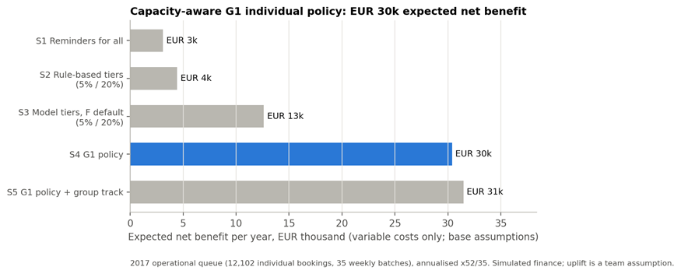
Figure 5.3. Net benefit per year by scenario (2017 queue, simulated)

Programme view (S4, 3 years of full operation from roll-out, undiscounted): year-1 net EUR 11.5k; 3-year net EUR 65.5k; ROI 173%; payback 6.9 months after roll-out. During the pilot only the treatment arm (half of eligible bookings) is contacted, so benefits before roll-out are smaller and are measured, not assumed.

Key findings:
- Value targeting beats contacting everyone. S1 earns only EUR 3.1k because backfire on low-risk guests nearly offsets the benefit. S4 earns ten times more.
- The model beats a simple rule, modestly. At the same shares it earns EUR 30.4k vs. EUR 28.8k for a segment × lead-time rule.
- Call uplift drives the case. Break-even uplift is 1.1% for calls and 2.0% for reminders. At zero call effect, S4 loses EUR 1.9k/year (programme ROI –82%). At 25%, net reaches EUR 78.8k.
- Other assumptions matter less.
  - Reminder uplift 0% / 8%: EUR 25.5k / 38.5k.
  - Resale 0.5× / 1.5×: EUR 40.3k / 20.5k.
  - Reminder backfire 2%: EUR 22.4k.
  - Call backfire 1%: EUR 26.5k.
  - Implementation cost EUR 30k: ROI 95%, payback 13.6 months.
  - Call time, attempts and SMS price: each < EUR 3.6k.
- Capacity holds. Calls average 16.5 per scheduled day (max 20). 17 tasks go to manual review.
- Overbooking (G3) stays off. It loses EUR 0.7k/year after relocation costs and is not recommended without a new capacity design.

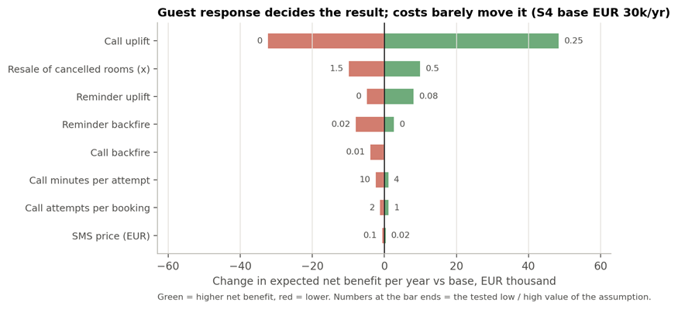
Figure 5.4. Sensitivity of S4 net benefit to each assumption

Occupancy, ADR and RevPAR (room-night ledger, stays 1 January – 31 August 2017, illustrative):
Scenario | Occupancy | ADR  (EUR) | RevPAR (EUR) | Contribution net*
S0 Actual 2017 | 78.7% | 116.96 | 92.02 | –
S4 G1 policy | 79.0% | 117.22 | 92.59 | EUR +20.6k
S5 S4 + group early release | 79.0% | 117.20 | 92.63 | EUR +21.3k
S6 S5 + price ±5% (elasticity −0.8, assumed) | 76.8% | 121.37 | 93.16 | EUR +85.6k
After variable costs, commission and room cost; before programme costs. Expected values from src/scenario_capacity.py, based on the 48,182 of 61,236 room-nights sold. The S4 result matches the queue simulation (EUR 20.5k over 35 weeks). S6 raises rates 5% on dates ≥ 85% occupancy and cuts them below 60%. Its elasticity is a team assumption (no price variation in the data), and at −1.2 or −1.5 RevPAR falls, so S6 is a pilot question, not a recommendation. Overbooking (G3) is not simulated as an option.

5.2.4. Evaluation plan
Level | Measure | How | Success criteria | Current status
Queue control | Queue size, call tasks/day, manual reviews | Action schedule, intervention log | ≤ 20 calls/day; manual review rare | Max 20/day; 17 tasks reviewed (2017)
Targeting quality | Cancellation rate and value share in contacted tiers | Method 1 weekly queue | Lift > 1; model ≥ rule | Call tier: 38.3% vs. 24.0% cancelled (lift 1.60), 44.8% of cancelled value. Call + reminder: 87.4%. Model top 20% precision 41.1% (rule 35.3%)
Business value | Net benefit, ROI, payback, break-even uplift | Scenario model, one-way sensitivity | Positive net under assumptions | S4 EUR 30.4k/year; ROI 173%; payback 6.9 months
Causal effect | Stay rate and contribution, treatment vs. holdout | Randomised pilot, assigned before contact, stratified by tier; analysed by assigned arm | Lower cancellation in treatment, with CI | Not yet available
Guest experience | Opt-outs, complaints, post-reminder cancellations (backfire) | CX monitoring by arm | No deterioration vs. holdout | Not yet available
Pilot sizing: a one-year, one-hotel pilot, followed by about four months until enrolled bookings reach their arrival date, can detect a reduction of about 5 percentage points as a stop / redesign / scale decision with CX guard-rails, or be pooled across more properties, not as proof of a precise effect.
Limitations:
- Uplift, backfire, cost and resale values are assumed or simulated, so results show logic and sensitivity, not measured return.
- The policy was chosen using a model selected on 2015 data and refitted before each 2016 decision, then applied to the final Method 1 model. The pilot must confirm the transfer.
- About 4,600 bookings in the 2016 selection queue had no outcome at the freeze date, under-representing very long-lead bookings.
- Snapshot features and the group-block proxy come from Method 1, so 2017 results are a retrospective prototype.
Output to the system (Tools): a weekly action queue and dated schedule per booking (booking ID, risk score, tier, rule, action, planned date, approval need), with the 17 unslotted call tasks flagged for manual review. Staff approve each week's routine plan before any contact is scheduled; n8n runs automatic actions in production, while in the prototype a demo workflow only checks and logs them. Approval-dependent actions wait for the Revenue Manager.

Tools and System Prototype
The prototype links booking-level risk estimation (Method 1), the capacity-aware decision policy (Stage G1) and an operational layer for staff: a web dashboard, an approval-guarded action store and an n8n workflow. It works on one fixed day, today = Monday 1 May 2017 (set at start with G2_TODAY), as staff would meet it in a pilot: the weeks before it have been handled through the same service and guards, and the e-mails and reminders of the batch scored yesterday wait for today's review (its calls were approved yesterday, as calls start on the scoring day). The dashboard, action store and n8n workflow are implemented and tested, but no guest is contacted and no PMS, price or inventory record is changed. Section 6.5 separates what is built from what remains a production design.

6.1. Technology Stack
The stack separates prediction, decision rules, data management and delivery:
- Python produces scores, tiers and dated actions.
- CSV/JSON files pass them, with a run identifier, to the operational layer.
- PostgreSQL holds the relational data model and, optionally, the shared action store.
- Streamlit provides the staff interface.
- n8n shows how an approved action is handed to a workflow.
Table 6.1 assesses each tool against the brief’s three criteria.

Tool | Role | Scalability | Collaboration | Usability for managers
Python (pandas, scikit-learn, XGBoost) | Weekly scoring (F), G1 tiers, capacity-limited schedule, scenario analysis | Weekly batch of new bookings; reproducible runs | Run ID and code/input hashes in each manifest | Invisible; results reach managers via the dashboard
CSV / JSON contract | Hands risk scores, action queue, dated schedule and G1 policy to the dashboard | Plain files now; same fields can move to tables or an API | Human-readable, versioned with code | Opens in a spreadsheet for review
PostgreSQL 16 | Hotel data model (10 tables, 2 views); shared action store with the same rules as SQLite | Constraints, indexes, multi-user access; writes serialised per store | One shared source for Reservations, Revenue Management and Finance | Managers never write SQL
SQLite | Local action store (default if no PostgreSQL address is set) | Single machine only | Not shared; one file per model run, policy and day | No set-up for a first demo
Streamlit | Dashboard: overview, risk queue with batch review, action review and approvals, execution and follow-up, capacity planning, performance, model monitoring, data scope | Fine for a pilot; needs login and server deployment at scale | Python code in the same repository | Filters, tables and buttons; no coding
n8n | Demo workflow: webhook, approval and execution guard, mock dispatch, reply | Workers and queues can be added in production | Visual nodes reviewable by operations staff | Readable sequence of steps
unittest + Node.js | Tests of data contract, guard rules, concurrency, workflow code and app | Full suite runs in about four minutes | Same checks for every team member | Not used by managers
Table 6.1. Technology stack, role in the prototype and assessment

6.2. Data Integration and Analytical Outputs
The selected XGBoost model (f-v3.1-2026-10-19) scores bookings created in each booking week that are still active at its end. For 2017 this gave 13,156 risk-score records: 12,102 individual bookings (XGBoost) and 1,054 group-block bookings scored by the group rule (segment × deposit), which go to the capacity track. Each record holds the booking ID, scoring time, model version, cancellation probability, risk tier, expected revenue at risk and days to arrival. G1 then re-tiers the individual bookings into a dated, capacity-limited action schedule (Table 6.2).
Output | Recorded result | Operational use
Risk scores | 13,156 records (12,102 individual, XGBoost; 1,054 group rule) | Cancellation probability and revenue exposure per booking
Decision queue (G1) | 12,102 bookings: I1 = 5,116; I2 = 5,186; I3 = 1,761; I5 = 39; 17 unslotted call tasks → manual review | Rule, tier and owner per booking
Action schedule | 20,563 dated actions: 5,116 confirmation e-mails, 13,703 reminders, 1,744 call tasks | Daily due list, imported into the action store once staff approve the weekly plan
Decision policy | Calls: top 15% per weekly batch by risk × value; contact: 60% of batch; ≤ 20 calls/day, within 7 days of decision and ≥ 8 days before arrival; G3 overbooking disabled | Keeps contact within staff capacity
Database structure | Hotel model: 10 tables, 2 views, checked by SQL scripts (30/30 pass). Action store (schema 9): 8 tables with guard triggers, on SQLite or PostgreSQL | Bookings, scores, actions, approvals, interventions, guest responses
Table 6.2. Analytical outputs used by the prototype (2017 evaluation period)

Before showing anything, the dashboard runs four checks:
- It confirms that the model and policy files come from the same run.
- It re-derives every G1 tier from the scores.
- It validates each dated action against the policy.
- It rejects any field known only after the outcome.
Outcomes (cancelled or not) are read only for bookings that arrived before today, to show what happened (Overview, Performance, Model monitoring) and to keep the prepared guest answers consistent; they never feed the queue, the schedule or a recommendation. Monetary figures shown to staff (expected revenue at risk; net value at risk on simulated costs) are scenario estimates, not realised or recovered revenue.

6.3. System Architecture and Workflow
The architecture follows the flow from booking data to risk estimation, decision policy and staff action (Figure 6.1). Analytical stages run as weekly Python batches and hand results over via the file contract. Staff work in the dashboard. Every proposal, approval, execution, guest response and closure is written to the action store, whose rules are enforced in both the service and database triggers. n8n receives an action only after these checks pass.
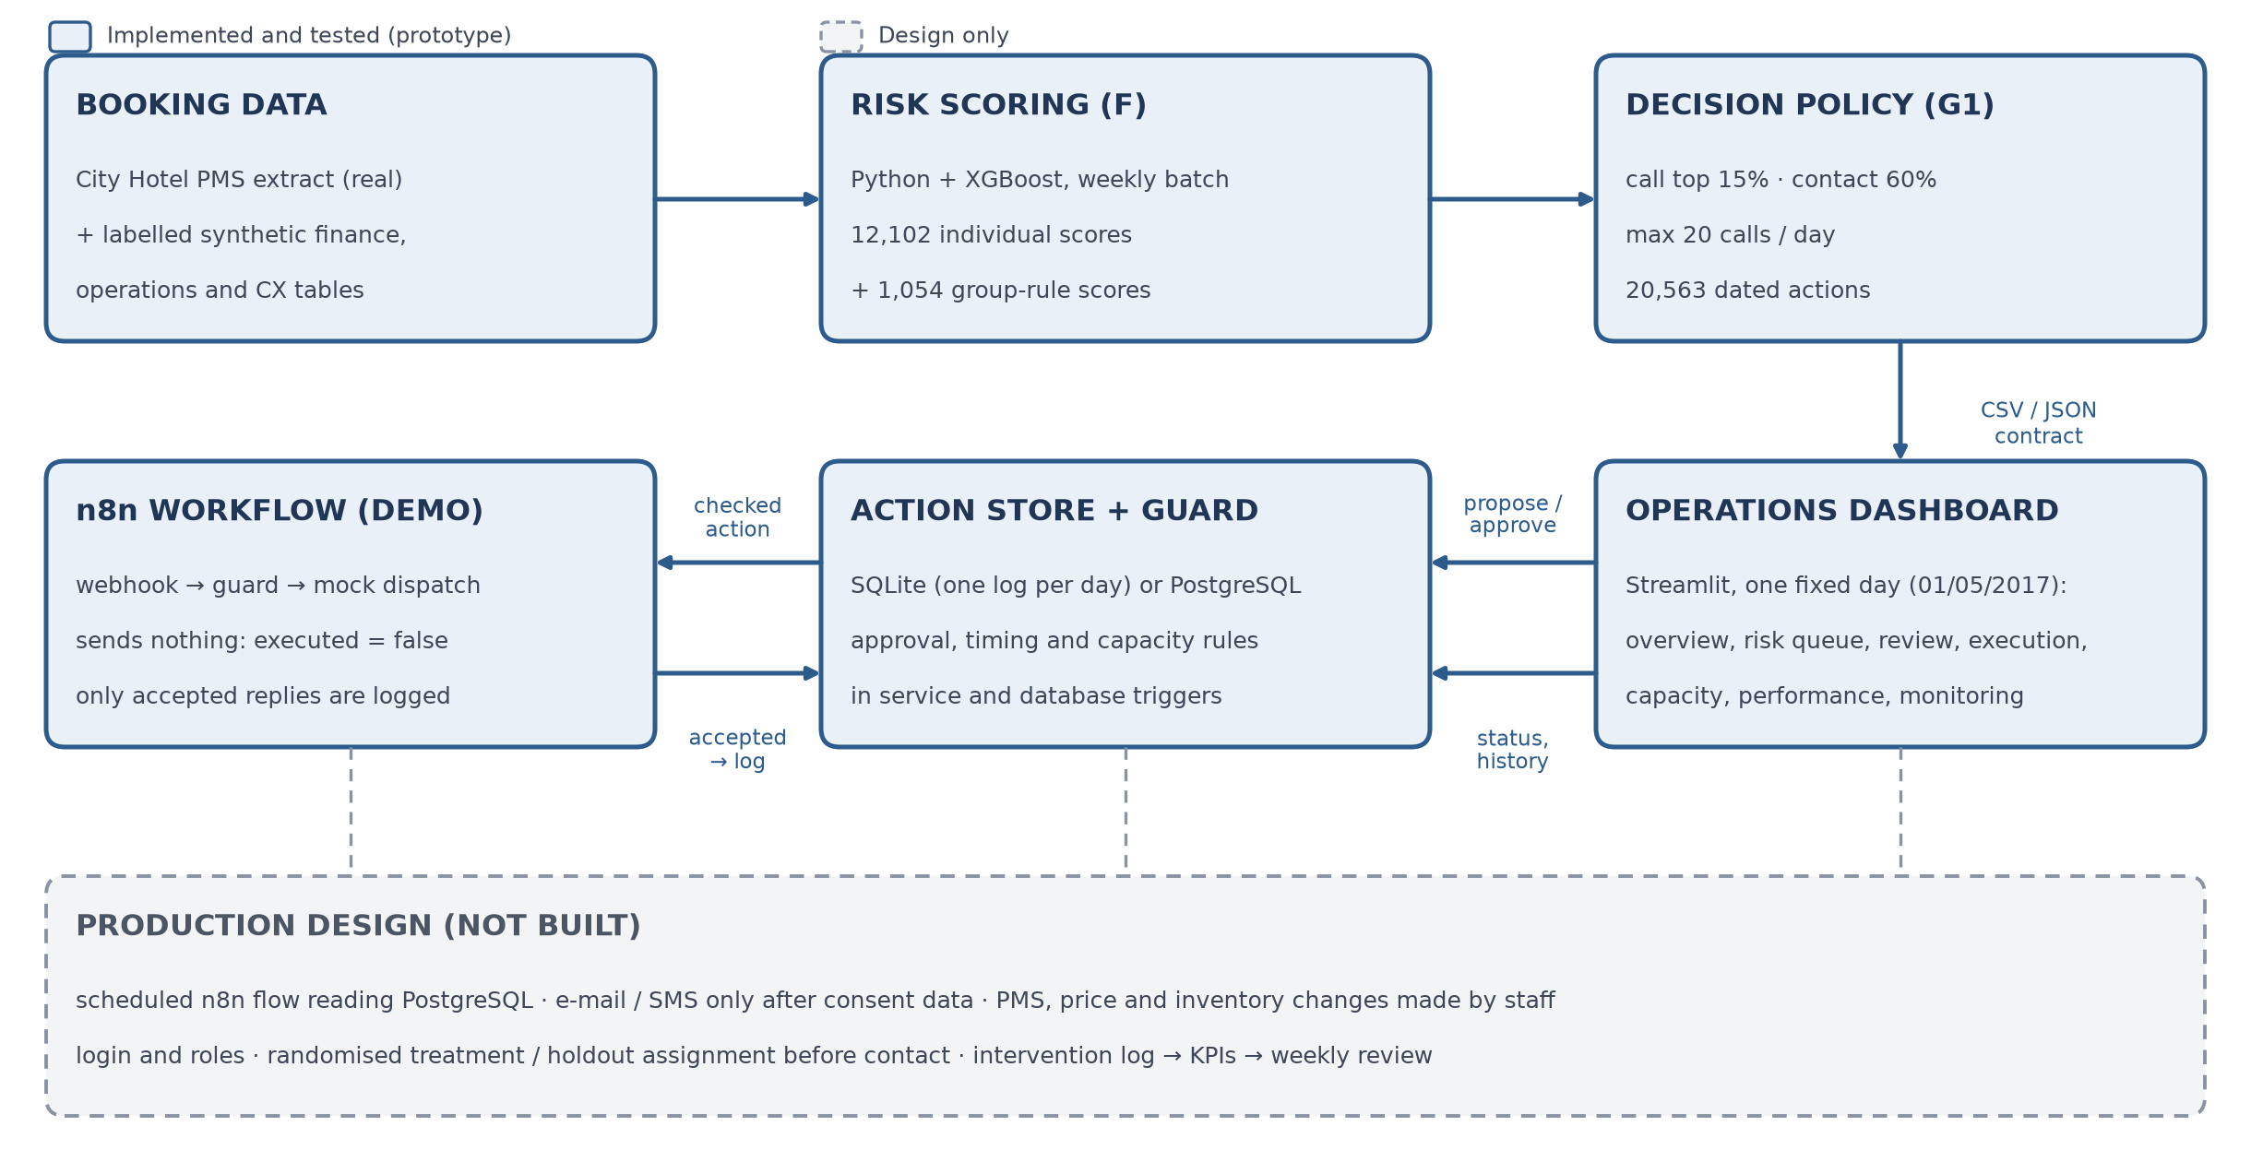
Figure 6.1. Technical architecture and booking-level decision workflow (solid: implemented; dashed: production design).
Before execution, the store checks that the action:
- is approved (or automatic);
- is not already executed or closed;
- is due today and falls before arrival.
It also checks that a call is still within the G1 window and the 20-per-day limit, that the guest has not already responded, and that no automated message goes out on the same day as a call. Consent, other open actions and whether the booking is still active are not in the data, so staff must confirm them for each guest action.
The checks, the n8n call and the log entry form one database transaction. As a result, concurrent staff cannot exceed the call limit or both close and execute the same action. Logs are append-only.

6.4. Dashboard and Automation Process
The dashboard centres on the day's work, not model diagnostics. It has eight pages, grouped as daily work, planning and analysis, and data:
- Overview: yesterday or the last 7 days (bookings scored, high risk, approvals, contacts, confirmations, arrivals, cancellations and how many the model had flagged), then today's work (Figure 6.2).
- Risk Queue: open bookings filtered by risk level, review and execution status and dates; routine recommendations approved in a batch, with a summary and a confirmation step.
- Action Review: one booking in depth; a recommendation rejected with a reason or an action replaced; sensitive actions approved one by one (Figure 6.3).
- Execution & follow-up: what is due today, calls and guest answers recorded, automation that refused or failed (with Retry), actions closed without contact, each booking's history.
- Capacity planning: expected cancellations per stay date × room type; room or price actions proposed for approval.
- Performance: operations so far and cancellations of the bookings already arrived (descriptive).
- Model monitoring: ROC-AUC, PR-AUC, Brier, top-20% precision, recall and lift, and deciles, recomputed on the bookings arrived before today.
- Data scope: sources, load checks, coverage and the fields that are not in the data.
Every page works from one fixed day, shown in a Today band with the latest scores, calls logged out of 20, actions planned for today and actions waiting for approval; nothing can run before its due date. Review status (has staff decided on the recommendation?) and execution status (has the action been carried out?) are kept apart, and nothing shows as sent or completed without a logged execution.
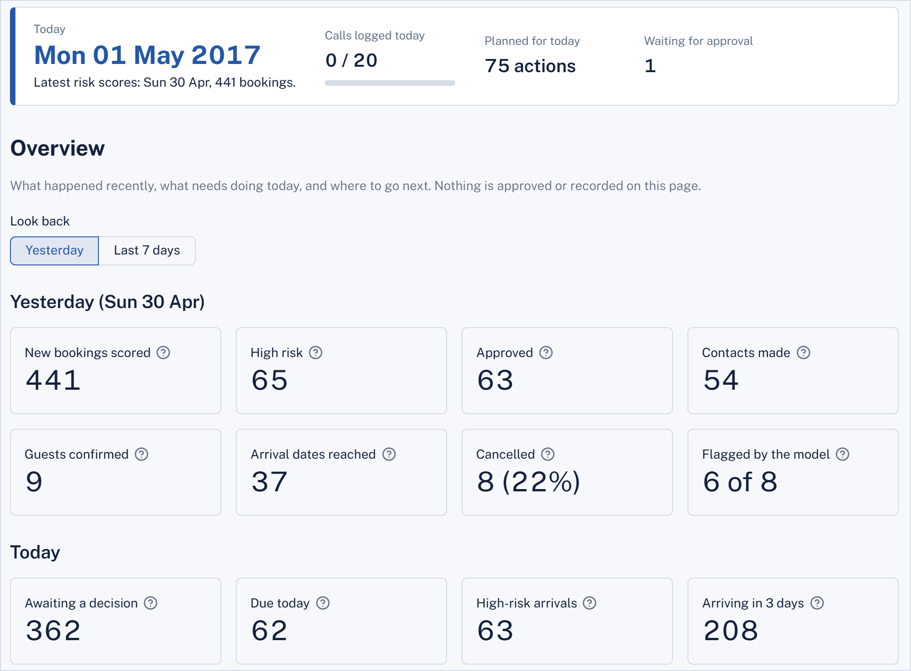
Figure 6.2. Overview on today, Monday 1 May 2017: yesterday's batch (441 bookings scored, 65 high risk, 63 calls approved) and today's work (362 decisions waiting, 62 actions due).
Prepared history. A new action log first receives the team's work up to yesterday, written once through the store's own service so every guard applies: routine recommendations approved on their scoring day, contacts carried out on their due date (e-mails and reminders through automation, calls by staff, at most 20 a day), follow-ups closed once a guest has answered, and one room-hold action a week approved by the Revenue Manager. The data hold no guest answers, so they are derived from each booking's real outcome and never contradict it: a guest who later cancelled never confirms. With today = 1 May 2017 this gives 9,039 approved recommendations, 1,332 calls and 8,876 e-mails and reminders.

Rule | Operational handling | Control measure
I1 – Standard | Confirmation on decision day + reminder 7 days before arrival (current practice) | Weekly plan review, then automatic; stops once the guest responds
I2 – Reminder | Personalised e-mail/SMS at 30 and 14 days before arrival (one at once if a milestone has passed) | Max 2; never on a call day; stopped by any guest response
I3 – Call | Reservations call task within 7 days of decision, highest risk × value first | Max 20 calls/day, 2 attempts per booking; outside window: manual review or close without contact
I4 – Offer change | Date or room change after a call where the guest asked to change | Revenue Manager approval, tied to that request; a newer request needs a new offer
I5 – Buffer only | Call-tier booking ≤ 7 days to arrival: no contact, counted in the buffer | Revenue Manager reviews the buffer
I6 – Deposit | Deposit request for a high-tier, no-deposit booking | Off by default; needs written policy and Revenue Manager approval
G1 – Group release ask | Ask the agent to confirm or release a block 30 days ahead (valued in scenario S5) | Not yet an action in the prototype
G2 – Capacity and resale | Capacity allocation or resale per arrival date × room type | Pending until a named Revenue Manager approves
G5 – Price change | Price adjustment per arrival date × room type | Pending until a named Revenue Manager approves; no tested price limits yet
G3 – Overbooking | Not available | Disabled; refused by the service, n8n and database
Table 6.3. Intervention routing and control rules
Approval is enforced in the database as well as the interface. A sensitive action starts as “pending” and cannot run until a named reviewer approves it (Figure 6.3). Approval decisions cannot be reversed or edited.
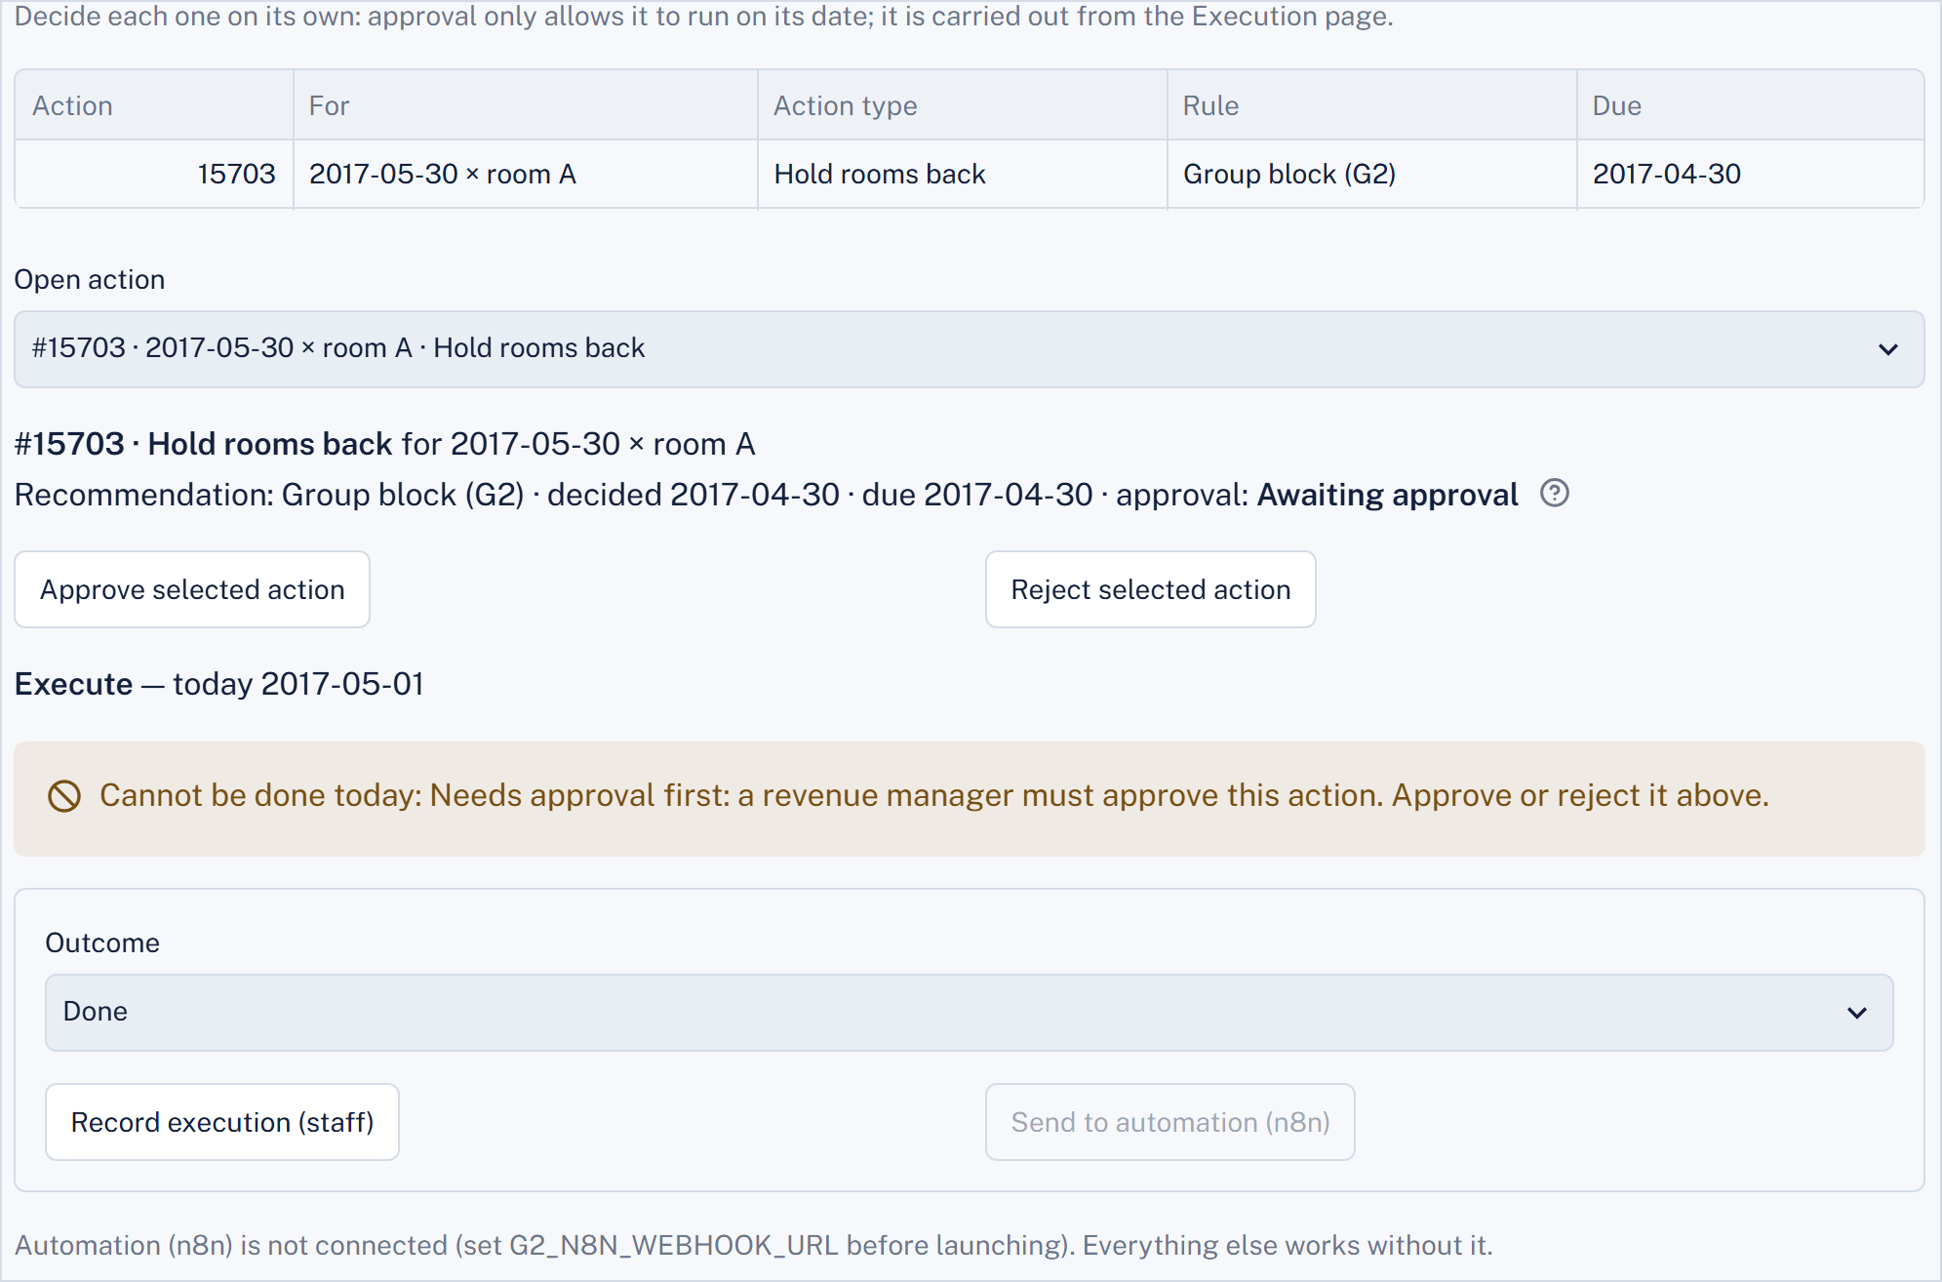
Figure 6.3. A pending capacity-allocation action (30 May 2017, room A) is blocked
until the Revenue Manager approves it.
For automatic and approved actions, staff either log execution themselves or hand it to n8n. n8n re-checks approval and timing, prepares what it would send (an e-mail preview, staff task or approval notice) and replies. Only an “accepted: true” reply is logged, as executed by n8n (Figure 6.4). In this prototype nothing is sent (“executed”: false).
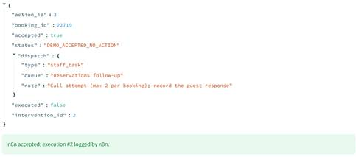
Figure 6.4. A call task handed to the local n8n workflow (recorded on 20/10/2026, n8n 2.43.8):
accepted, logged by n8n, nothing sent.

6.5. Verification and Limitations
Check | Result
Automated tests, SQLite store | 263 tests pass (5 skipped: 2 need live n8n, 3 need PostgreSQL), 21/10/2026
Action-store tests, PostgreSQL 16 | 172 tests pass (4 skipped: 2 SQLite-file only, 2 need live n8n), 20/10/2026, before the history and monitoring tests were added
Live n8n workflow (local) | Approved call accepted and logged; pending action and overbooking refused by n8n’s own guard (n8n 2.43.8, 20/10/2026)
Concurrent staff sessions | Last call slot goes to one session only; an action cannot be both closed and executed; each action reaches n8n once
Database scripts | Data load 30/30 checks; approval-guard migration 19/19 checks
Table 6.4. Verification of the prototype
Limitations:
- The prototype has no login or user roles, holds no guest contact details and contacts no one.
- Consent and open actions are not in the data, so staff must confirm them.
- The n8n workflow is a demonstration. In production it would run on a schedule, read due actions from PostgreSQL, send e-mail/SMS only once consent data exist, and leave PMS, price and inventory changes to staff.
- Pilot treatment/holdout assignment, needed to measure the real effect of contacts, is designed but not implemented.
- All financial figures remain scenario estimates.
- The history up to today is prepared, not observed: approvals, contacts and guest answers are generated by the system's own rules, and the answers are derived from each booking's real outcome.

Implementation Roadmap
We propose a 22-month path to a scale decision: five months to prepare and shadow-run the system, a 12-month randomised pilot, four months for pilot bookings to reach their arrival date, and one month to evaluate before the hotel commits to roll-out.
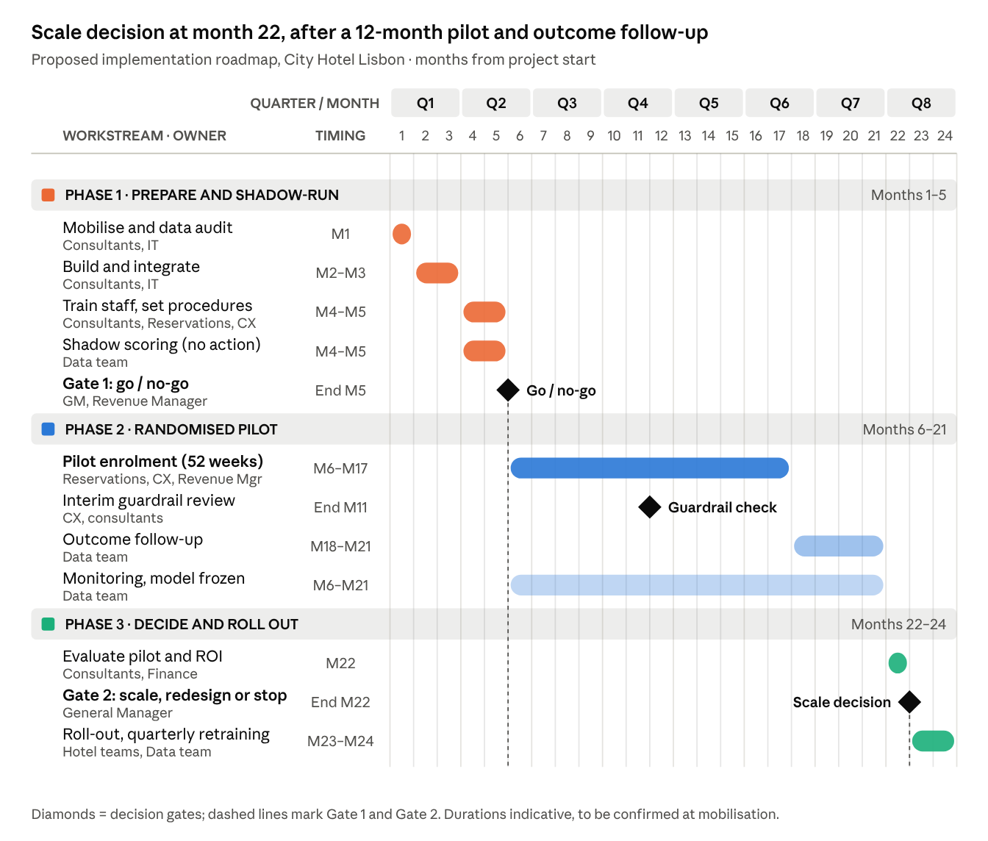
Figure 7. Implementation Roadmap for Lisbon

REFERENCES
Alkan, T. Y. (2025). A comparative study of machine learning and deep learning approaches for hotel booking cancellation prediction. International Journal of Scientific Research in Engineering & Technology, 5(3), 11–18. https://doi.org/10.59256/ijsreat.20250503002
Antonio, N., de Almeida, A., & Nunes, L. (2017). Predicting hotel booking cancellations to decrease uncertainty and increase revenue. Tourism & Management Studies, 13(2), 25–39. https://doi.org/10.18089/tms.2017.13203
Antonio, N., de Almeida, A., & Nunes, L. (2019). Hotel booking demand datasets. Data in Brief, 22, 41–49. https://doi.org/10.1016/j.dib.2018.11.126
Cha, J. (2026). Machine learning-driven overbooking optimization under dynamic cancellation risk: Evidence from hotel revenue management. Computers & Industrial Engineering. Advance online publication. https://doi.org/10.1016/j.cie.2026.112341
Chen, Y., Ding, C., Ye, H., & Zhou, Y. (2022). Comparison and analysis of machine learning models to predict hotel booking cancellation. In Proceedings of the 2022 7th International Conference on Financial Innovation and Economic Development (ICFIED 2022) (pp. 1363–1370). Atlantis Press. https://doi.org/10.2991/aebmr.k.220307.225
Dong, Y., & Ling, L. (2015). Hotel overbooking and cooperation with third-party websites. Sustainability, 7(9), 11696–11712. https://doi.org/10.3390/su70911696
Gurol-Urganci, I., de Jongh, T., Vodopivec-Jamsek, V., Atun, R., & Car, J. (2013). Mobile phone messaging reminders for attendance at healthcare appointments. Cochrane Database of Systematic Reviews, (12), CD007458. https://doi.org/10.1002/14651858.CD007458.pub3
Hans-Böckler-Stiftung. (n.d.). WSI minimum wage database: Portugal. https://www.boeckler.de/pdf/ta_portugal_mwdb.pdf
Hermawan, A., Saputra, A., Lailinajma, N., Julianti, R., Hartanto, T., & Daniel, T. K. (2025). Predicting hotel booking cancellations using machine learning for revenue optimization. Router: Jurnal Teknik Informatika dan Terapan, 3(1). https://doi.org/10.62951/router.v3i1.400
Luo, Z. (2025). Hotel cancellation rate prediction: A machine learning based prediction model. In Proceedings of the 2025 3rd International Conference on Image, Algorithms, and Artificial Intelligence (ICIAAI 2025) (pp. 318–327). Atlantis Press. https://doi.org/10.2991/978-94-6463-823-3_31
Mandelbaum, R., & McDade, G. (2017, February 21). The rising cost of rooms. LODGING Magazine. https://lodgingmagazine.com/the-rising-cost-of-rooms/
Pimentel, V., Aizezikali, A., & Baker, T. (2019). Hotel revenue management: Benefits of simultaneous overbooking and allocation problem formulation in price optimization. Computers & Industrial Engineering, 137, Article 106073. https://doi.org/10.1016/j.cie.2019.106073
Regulation (EU) 2016/679 of the European Parliament and of the Council of 27 April 2016 on the protection of natural persons with regard to the processing of personal data and on the free movement of such data (General Data Protection Regulation). (2016). Official Journal of the European Union, L 119, 1–88. https://eur-lex.europa.eu/eli/reg/2016/679/oj
Rushmore, S. (2011, November 7). Comparing same hotel across five regions. HVS. https://www.hvs.com/article/5529-comparing-same-hotel-across-five-regions
Salários médios sobem no turismo, mas ainda não vão além dos 632 euros [Average wages in tourism rise but still do not exceed 632 euros]. (2018, February 19). Diário de Notícias. https://www.dn.pt/dinheiro/interior/salarios-medios-sobem-no-turismo-mas-ainda-nao-vao-alem-dos-632-euros-9128393.html
Schegg, R. (2018). European hotel distribution study: Results for the reference year 2017. Institute of Tourism, HES-SO Valais; HOTREC. https://turob.com/assets/Haberler-Dosyalari-image/European-hotel-distribution-study-final-results.pdf
Toulon, A. (2014, May 28). Booking, Expedia… les hôteliers sont-ils vraiment perdants ? [Booking, Expedia… are hoteliers really the losers?]. Europe 1. https://www.europe1.fr/economie/Booking-Expedia-les-hoteliers-sont-ils-vraiment-perdants-660490
van Leeuwen, R., Do, H. D., & Koole, G. (2025). Churn management in hospitality. Journal of Big Data, 12, Article 145. https://doi.org/10.1186/s40537-025-01204-8
Yoo, M., Singh, A. K., & Loewy, N. (2024). Predicting hotel booking cancelation with machine learning techniques. Journal of Hospitality and Tourism Technology, 15(1), 54–69. https://doi.org/10.1108/JHTT-07-2022-0227

